**Attachment F**

**How to Place a DRAFT Watermark in a Document**

1. In the **Page Layout** tab, **Page Background** box, click on the **Watermark** drop down arrow**.**

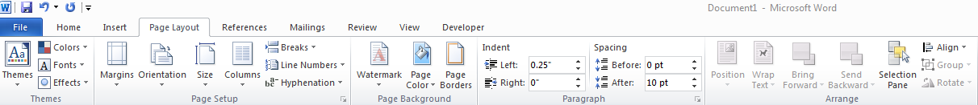

1. Scroll down to **Disclaimers** and click on either **Draft 1 or Draft 2** that will appearin the drop down box to insert the watermark in your document.
2. To remove a watermark, follow Step 1.Click on the **Remove Watermark icon** on the bottom of the drop down menu.
3. When you send your policy for review and approval, the reviewer will see the draft watermark on the document.

**How to Turn On Track Changes When Revising a Policy**

1. In the **Review** tab, **Tracking** box, click on the **Track Changes** drop down arrow.

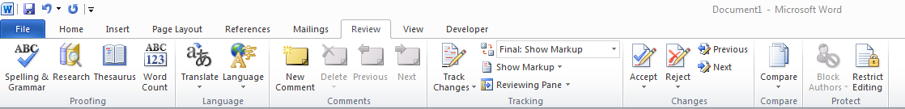

1. Click on the **Track Changes icon** that will appear.
2. Next, make sure that **Final: Show Markup** is selected.

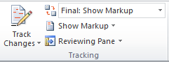

1. When you send your policy for review and approval, the reviewer can now see the revisions you made to the document. Revised text appears in red, deleted text will have a red line drawn through it.